

GROUP DOGE

UNIVERSITY OF QUEENSLAND  INFS2233

Urban Culture Co.

**BUSINESS PLAN**

**URBAN CULTURE CO.**

**INFS2233**

**eBusiness Systems and Strategies**

BOARD OF DIRECTORS:

LIAM SIMPSON – 43939871

JAMES BENTLEY –

NICOLE WESTON –

AARON LANE –

# Executive Summary

Urban Culture Co. is forged upon the ideals of its co-founders and prioritises many important features of corporate culture, effective time management, efficient trading and many more. Urban Culture is an Australian company located on the internet, registered under the domain [www.urbanculture.com.au](http://www.urbanculture.com.au). Many important scenarios and strategies have been included in this business plan and incorporate one or multiple strategies for various headings and topics. The four functions of a business or corporation have been used to strategize, which includes; Marketing, Operations, Human Resources and Finance. The document has been structured to include more detailed information on the four functions of a business/corporation and few of many more topics involved include; Business Profile, Business and Revenue Models, Industry and Market Analysis, target markets and market trends, competitors, Marketing Plan, Operating Strategies, supply chain management, the production process, Human Resources Strategies, website design and implementation strategies and a financial strategy analysis.

Many elaborate considerations have been incorporated in the various strategies used to plan to organisations hierarchy of employment, this includes a very elaborate table of the requirements successful applicants must provide and the roles, responsibilities and the wages that are applicable to the employees of Urban Culture Co. Urban Culture has recognised its competitors, industry and ideal marketplace and understand the importance of team work, planning and effective management.

Table of Contents

Executive Summary 1

1.0 Business Profile 4

1.1 Introduction 4

1.2 Mission Statement 4

1.2.1 Description of Mission Statement 4

1.3 Legal Structure and Ownership 4

1.4 Distinctive Competitive Advantage 4

1.5 Goals and Objectives 4

1.6 History 4

1.7 Business Model 4

1.8 Revenue Model 4

2.0 Industry and Market Analysis 5

2.1 Introduction 5

2.2 Market Size 5

2.3 Market Trends 5

2.4 Target Market 5

2.5 Competitors 5

2.6 Market Demands 5

2.7 Opportunities 5

2.8 Future Opportunities for Urban Culture Co. 5

3.0 Marketing Strategies 6

3.1 Product 6

3.2 Price 6

3.3 Place 6

3.4 Promotion 6

4.0 Operating Strategies 7

4.1 Supply Chain 7

4.1.1 Suppliers 7

4.1.2 Facilities 7

4.1.3 Equipment 7

4.1.4 Shipping 7

4.1.5 Inventory 7

4.1.6 Customer Support 7

4.2 Production Process 7

4.3 Contingency Planning 7

4.4 Project Management Team 7

5.0 Human Resource Strategies 8

5.1 Personnel and Skill Sets 8

5.2 Organisational Hierarchy 8

5.3 Recruiting 8

5.4 Retaining 8

5.5 Award Rates 8

6.0 Website Design and Implementation 9

6.1 Security 9

6.2 Direct Denial of Service (D/DOS) 9

6.3 Version and Application Vulnerabilities 9

6.4 Port and Server Vulnerabilities 9

7.0 Financial Strategy 10

8.0 Bibliography 11

9.0 Appendix 12

9.1 Appendix A 12

9.2 Appendix B 12

# Business Profile

## Introduction

Urban Culture Co. wishes to thrive in the online retail environment selling electric skateboards in recreation and leisure retail industry online. Online sales have increased since 2011 from $237.1 billion to $266.8 billion according to the Australian Bureau of Statistics[1]. This data proves that the online industry is becoming increasingly popular among Australians and a reliable market for a business venture. International providers of electronic skateboards are occupying this potential market due to limited competitors. The market is heavily controlled by popular online businesses shipping globally, however the Australian market shows significant potential. It’s important to consider the fundamental aspects of managing a business prior to starting one, this can heavily influence the planning process and procure long-term benefits. In order to provide the most effective customer service, business management must understand the needs and qualities of the target audience. Urban Culture Co. prioritises the development of its reputation as the founders understand the importance it has in relation to creating a strong, sustainable business. This is especially true for Urban Culture, an online business, weighted and reviewed heavily by critics and users of social media.

## Mission Statement

***““It is Urban Culture’s mission to get the whole of Australia rolling with their unique electronic, motorised skateboards at the most affordable prices in conjunction to superior customer service and retail innovation.””***

### Description of Mission Statement

Urban Culture Co. operates and markets its business to thrive in the online retail environment by providing excellent online customer service and by striving to become the leading Australian retailer of electronic skateboards online. Security, professionalism, quality, speed and innovation represent few of the important qualities Urban Culture Co. is built upon.

## Legal Structure and Ownership

The legal structure a business operates under may differentiate according to a number of underlying factors. Urban Culture Co. will operate legally as A company/corporation complying with the statutory rules of the Queensland government[2]. A corporation requires a team of board of directors and registration. As a long-term goal Urban Culture Co. intends to expand upon corporate success and grow the company to appeal to an international consumer market.

## Distinctive Competitive Advantage

Design is a key concept to uphold when targeting a niche market such as the skateboarders of Australia. Skate-boarders are unique people and it’s shown that board art is wildly popular within the community. Urban Culture Co. plans to be advantageous upon this market characteristic and provide a limited but wide assortment of board designs. Customers will be provided the option to select their board and their design and view it prior to purchase.

## Goals and Objectives

|  |  |  |
| --- | --- | --- |
| **Goals and Objectives** | | |
| Short-Term  (1-6 months) | Medium-Term  (6 months-3 years) | Long-term  (3+ years) |
| Manufacture and sell a minimum of 50 units | Design 10 additional boards | Upscale resources including inventory, staff and property by 25%. |
| Obtain 200 likes on Facebook page | Multi-language web page compatibility | Expand to international marketplace |
| Advertise on general/social media | Receive a loan of $200,000 | Manufacture new products (i.e. accessories, clothing etc.) |
| Earn a profit on monthly trading | Purchase a corporate office/warehouse | Recruit experienced managers and employees for customer support and manufacturing |

## History

Urban Culture is a product of four university students coming together to create and sell electronic motorised skateboards that are both unique and interesting. Urban Culture provides a core competency of competitively low prices. Additionally, the idea to design boards with various different designs materialised after group research at university uncovered the potential for this product in the market. It was believed that providing these designs would attract more customers to the industry.

The founders and members of the board of directors; Liam Simpson, Nicole Weston, James Bentley and Aaron Lane all live in Brisbane in a variation of suburbs and have been for many years. For an average of 6 months the ideal focus has been implementing strong E-Business strategies for starting the business.

The ideals of the business are primarily a reflection of the motivation and reason of the founders and specifically entails supporting avid skaters and technology enthusiasts to purchase one of Urban Culture’s motorised boards and explore the world, just that much cooler.

## Business and Revenue Models

## ***\*Please refer to Appendices # and # for the business and revenue models\****

# Industry and Market Analysis

## Introduction

The market analysis will look at the market size, current market trends for the product, the target market, market share and segmentation, competitors and will briefly touch on the future of the company and product line. The market analysis will only examine the competition and trends within however, more specific information on our product specifically can be found in the marketing section.

## Market Size

It’s hard to gauge the exact market size as the market itself is a niche market and the trend for electric skateboards and other like devices are only recently starting to really take hold. Due to the niche nature of the market there is not much data on electric skateboards specifically however, many retail sites for them do exist. There is a trend towards rideable electric devices currently though most recently one called a ‘hover board’ which is basically a Segway without the handle to this and skateboarding and skateboards will be the focus of the analytic data.

## Market Trends

There is a current trend and large interest in electric skateboards and ‘hover boards’ based on google search analytics. Google analytics in the new dashboard normalises data to make them based out of 100 for comparison purposes between search topics but a clear trend can be seen on a searches over time basis. The other key defining point about our product is the ability to customise which is currently popular with the rise of sites allowing users to buy custom skins for things like phones and laptops as well as many sites offering custom print clothing and other items. (see appendix A figure 1 and 2 for search trends over time. Figure 3 is provided for a comparison of the other 2). Another substantial trend is people wanting to customise their products with 36% of consumers saying they are interested in personalised products and services according to market research firm Deloitte. From the same figures 43% of 16-24 year olds and 46% of 25-30 year olds surveyed stated they were attracted to personalised goods and services[3].

## Target Market

Using sites for market analysis the following can be learned about the target demographic. There are no results available for electric skateboards, hover boards, booster boards or any other competitor however, there are results for the interest of ‘skateboarding’. From the data for skateboarding as an interest based the sample of the population the person is generally likely to be male, most fall into the 18-35 age range, positive correlation is shown with urban areas and negative correlation with rural areas, there is a

, most have high disposable income. Generally, there is an observed knowledge of technology with computer programming having a high positive correlative relationship as well as guidingtech.com, github.com and xero.com having high positive relationships suggesting good knowledge of computers and software. Most are active with fishing, hunting and rock climbing having high positive correlative relationships. It is interesting to observe there is a high negative correlation with traditional media companies. Additional observations are that most of those who like skateboarding are on the left or ‘liberal/ progressive’ side of politics and are not into traditional media like TV and print. Additionally, when looking at most categories sorted by percentage of positive responses of the overall UK population there is a negative Z score meaning that those who like skateboarding gave more negative responses to those questions than the general population did, from this it can be determined that there is a ‘going against the grain’ trend.

Other information about the target market is statements the target demographic strongly agree with are “I like to stand out” and “I keep up with current fashion trends” and the most common self-described personality traits are talented (Z= +6.1) and Thinker (Z= +5.0) which have a high positive correlation with the target demographic. Quiet (Z= -6.3) and Organised (Z= -7.4) showed the strongest negative correlation to the target demographic[4] (see appendix A, figure 4 for a full table of the important data and correlation data).

## Market Segmentation

In terms of market segmentation geographical is not a concern for the business as the business is entirely online and international so the company can operate from just about anywhere and ship products almost anywhere however, based on the price of the current product it is expected that the target market would be those in wealthier countries.

{I’ll probably need to end up adding more to here}

## Competitors

There doesn’t appear to be any competitors who are doing exactly what we are doing however, there are still indirect competitors and the risk of new competitors entering the market. For example, the companies listed below all do electric skateboards and are thus indirect competitors. The risk however is if new competitors because the idea of customisation of things and skins for things is not a unique idea or one that is patentable due to the very broad nature of the idea. Hence, the strategy is to get in while no one else is doing it and establish a brand in the market and from there the company would be able to compete with others doing the same thing because of economies of scale.

**Various companies | Hover boards/ self-balancing Segway** – These boards consist of two wheels which are horizontal to the person’s feet. Each foot has a pad under it which can be used to control the board. These boards specifically however are the subject of a lot of problems because of government's moving to ban them in public places. This and there are a lot of companies making the same product and a lot have been manufactured to poor standards and have a substantial risk of catching fire and Segway is currently in a legal battle with these companies over patent infringement. This range in price from US$300 to around US$700.

**fiikelectricskateboards.com.au | various motorised skateboards in traditional styles –** The offering from this company consists of multiple boards ranging from AU$1,500 to around AU$1,700 for the lithium battery models. These boards resemble traditional skateboards with exception to overall shape and wheels on the board. The competitor offers multiple board offerings but have no real customisation options to be seen.

**boostedboards.com | boards which are all the same look wise and differ in specifications –** The boosted boards are all the same design just with different specification (e.g. higher range, larger battery, faster top speed). The range from US$999 for the base model up to US$1,499 for the boosted dual+ model. They have no real customisation available in terms of look or design.

## Market Demands

As has previously been identified in the market trends and target markets sections there is a significant demand for the product and customisation. In a report that looked at outdoor activities those aged 6-17 engaged in it was found that in the United States almost 6.62 million Americans have and do participate in skateboarding with 3.8 million being aged 6-17 and 1.15 million being aged 18-25[5]. The same report also states that it is the 3rd most popular behind only running, jogging and train running in first place and road biking, mountain biking and BMX in second place.

Our target market discovered fall into these age categories based off the interest of skateboarding. Based off the research from yougov.co.uk there is a high amount of positive agreement with the statement “I like to stand out” among those interested in skateboarding. Other demand identified was the demand for personalised goods where market research showed that 36% of consumers said they are interested in personalised products and services with 43% of 16-24 year olds and 46% of 25-30 year olds surveyed stated they were attracted to personalised goods and services. From the same information it states that “businesses who do not offer an element of personalisation risk losing customer loyalty and revenue over the long term” with 71% of people stating they would be willing to pay a premium for a personalised product[6].

## Opportunities

The opportunities presented to our business are the demand for customers to be able to customise their stuff which we have been seeing in other areas but none in the skateboard market let alone electric skateboard market which none were identified. Based on the trend for rideable electric devices and customer profiling and the market research of other firms identifying a demand for personalisation we have identified this opportunity as our main and primary goal. Another opportunity for the business is the low cost of offering customisation as the material used in the customisation process would be printed vinyl which is durable, cheap to buy in large amounts and allows us to print directly to the material personalise Miller's (2003) analysis of Internet company designs. The added bill of materials (BOM) cost is insignificant and as board designs change and we manufacture different boards there would be minimal retooling cost and will allow us to keep the added BOM cost of personalisation low.

## Future Opportunities for Urban Culture

The future of the company is firstly to manufacture and customise electric skateboards for consumer use, this is our starting point and how we will get into the business. Later down the line in the future due to the reasonably low cost of creating vinyl skins and the fairly high demand for customisation the company would look into selling just the skins without the products. This would mean all we would need to do is have the dimensions for a given device then it would be easy to custom print skins. There is a competitor in this market dbrand.com who offer this service but don’t offer users the ability to upload their own images for customisation.

# Marketing Strategies

## Product

***\*\*I am determining the price by updating the larger Income statement in excel so this may change slightly when I am done\*\****

Urban Culture will manufacture and distribute high quality, custom painted motorized skateboards at a reasonable cost and substantial profit. There are four main facets to the Urban Culture motorized skateboard that will set them apart from all other motorized skate boards on the market: 1) High quality and competitive pricing, 2) Customized paint jobs that allow customers to choose from our wide range of personalized Urban designed boards, 3) Custom paint jobs on customer’s own existing skateboard, encouraging for more frequent repeat customers, and 4) Frequent competitions allowing customers to interact with Urban Culture and the UC community by submitting and voting on board designs. The winning design of these competitions will be made into a limited edition paid design and the winner will receive a free Urban Culture board, customized with their limited edition design. Urban Culture will be more than just a product/service distributor; Urban Culture will be a community of highly dedicated customers.

Initially, the product will be assembled and custom painted in Australia in a small garage setting by UC, however, as demand increases this process will need to be modified. The individual components of the Urban Culture boards will be manufactured overseas in an effort to lower costs, so we can maintain competitive pricing. Three separate, Chinese, manufacturing companies have been chosen as suppliers due to their competitive pricing, quality of product and the current China-Australia Free Trade Agreement (ChAFTA).

The estimated initial board production per month will be !!!!___!!!! boards. However, as Urban Culture moves from start-up and gains a foothold in the market we estimate this level will drastically increase. There are three main board components; deck, motorized wheels and grip.

The deck will be manufactured by Gamer Gear in Guangdong, China. The board will be 114x23cm and made of high quality 8 Ply Full Canadian Maple. They offer free product sampling to ensure that the quality is to the Urban Culture standard. The Supplier capacity is 80000 pieces per month (well above our initial estimated demand rate) which will prevent any bottlenecking between supply and delivery of finished product.

The Motorized wheels will be manufactured by Guangzhou WOW Electronics Technology Co., Ltd. in Guangzhou, China. The motors are quick to mount and assemble (taking around 5 minutes per board). The motorized wheels have a noise-less dual motor, two drive speed modes and a remote control unit. The motor can drive the wheels as fast at 30km/hr, only takes 1.5 hours to fully charge and has protection from water spray from any direction and limited dust ingress (IP54). The supplier capacity is 4000 sets per month (1000 sets per week), which well is above our initial estimated demand rate. Full motorized specs are as follows:

|  |  |
| --- | --- |
| BASIC INFORMATION | |
| PERFORMANCE | |
| Top Speed | 30km/hr |
| Max Mileage | 15-20 KM (Single/Dual Motor) |
| Climbing Capability | 25° |
| Battery | 36V 4.4 Ah Lithium Battery |
| Charging Requirements | AC110 ~ 240V; 50 ~ 60Hz |
| Charging Time | 1.5Hrs |
| Best Working Environment | 25°C |
| Waterproof level | IP54 |
| Suitable | 7-60 Years |
| HARDWARE | |
| Motor Type | Compact Electric Motor |
| Wheel Specs | 70mm 82 TPU |
| Truck and Frame | ADC12 Aluminium Alloy |
| Max Loading Weight | 150 KGS |
| Size | 375x265x95 mm |
| Net Weight | 2.5 KGS/3.5 KGS (Single/Dual Motor) |

The transparent grip tape is manufactured by Shanghai Hangyao Trading Company Limited in Shanghai, China. It is made of a high quality, environmental PVC substrate and silicon carbide. The supplier capacity is 1 billion sheets per month, which well above our initial estimated demand rate. The purpose of the clear tape is to lengthen the life of the custom paint as well as provide skaters with grip at higher speeds.

## Price

***\*\*I am determining the price by updating the larger Income statement in excel so this will change\*\****

|  |  |  |  |
| --- | --- | --- | --- |
| **Costs** | **Unit cost** | **Quantity/Month** | **Total Cost** |
| Product Components |  |  |  |
| Motorized Wheels | $250 | 1000 |  |
| Deck | $21.81 | 1000 |  |
| Clear Grip Tape | $1 | 1000 |  |
| Paint |  |  |  |
| Office equipment |  |  |  |
| Workers’ Wages |  |  |  |
| Domain |  |  |  |
| Shipping Costs |  |  |  |
| Advertising Costs |  |  |  |
| Electricity |  |  |  |
| Accounting, Payroll and Taxes |  |  |  |
| Outsourcing server  http://www.cera.net/client-specific-technical-solutions/technology-server-outsourcing |  |  |  |
| Set-up costs (Month 1) i.e. trademark etc.. |  |  |  |
| Legal fees |  |  |  |
| Plant |  |  |  |
| Rental of garage (for tax purposes) |  |  |  |
| Insurance |  |  |  |
| Shipping costs |  |  |  |

## Place

## Promotion

# Operating Strategies

## Supply Chain

### Suppliers

The suppliers we have sourced are all located in China. Gamer Gear Sporting Goods Co., Ltd. will supply the decks. The motor and remote will be sourced from Guangzhou WOW Electronics Technology Co., Ltd and the transparent grip tape will be supplied by Shanghai Hangyao Trading Company Limited.

### Facilities

Initially the company will be working out of a garage in order to minimise costs. This will be used as the operational office of the company as well as a place to house the inventory. As the company grows, this will change and the inventory will be stored in a warehouse, whilst office space will be used for the operational side of the company.

### Equipment

The assembly of the boards is very simple and will only require a few tools and materials. This will include a power drill, screws and glue. The main equipment needed will be a computer and office desk for each employee.

### Shipping

The suppliers in China will send the materials to our office in Australia, where the skateboards will then be assembled. Once an order of a skateboard has been made, we will build the product according to the customer’s specifications and send the skateboard to the customer. In order to ensure a fast and timely delivery, a courier company such as FedEx or DHL will be used to ship the product. As FedEx and DHL are global companies, the skateboards will be able to be shipped to almost anywhere in the world.

### Inventory

To start with the inventory will be stored in the garage that we will be working out of. However, as the company expands, the inventory will be stored in a warehouse. This will offer much more security as well as increased storage space.

### Customer Support

The website will feature a contact form which will allow customers to make an enquiry or a complaint about the company or product. Customer support is highly regarded by the company and all complaints and enquires will be looked into fully and resolved as quickly as possible.

## Production Process

The materials will be shipped over from China to Australia, where the boards will be assembled. The assembly time for each board will be around one day. This process involves the board being painted, the grip tape being put on followed by the trucks and wheels being screwed on. The time-consuming part of this process is waiting for the board to dry after being painted.  Based on two people working on the assembly, expected max output is five boards per day.  This will obviously increase as the company grows and hires more workers.

## Contingency Planning

## 4.4 Project Management Team

# Human Resource Strategies

## Personnel and Skill Sets

Urban Culture Co. has designed been designed to best operate with 10 employee personnel on a casual wage required to attend four working days during the week. Urban Culture does not require its employees to attend work during the weekend, no trading and/or manufacturing occurs on these days.

Urban Culture is looking for specific qualities and skills from its applicants. Successful applicants will possess many if not all the required qualities and skills. Successful applicants will be required to stand for prolonged periods at one time and possess above average communication skills and technical knowledge. They must have experience working in manufacturing and some evidence of customer service experience. All employees will be provided with the tools and equipment to perform their jobs effectively.

## Organisational Hierarchy

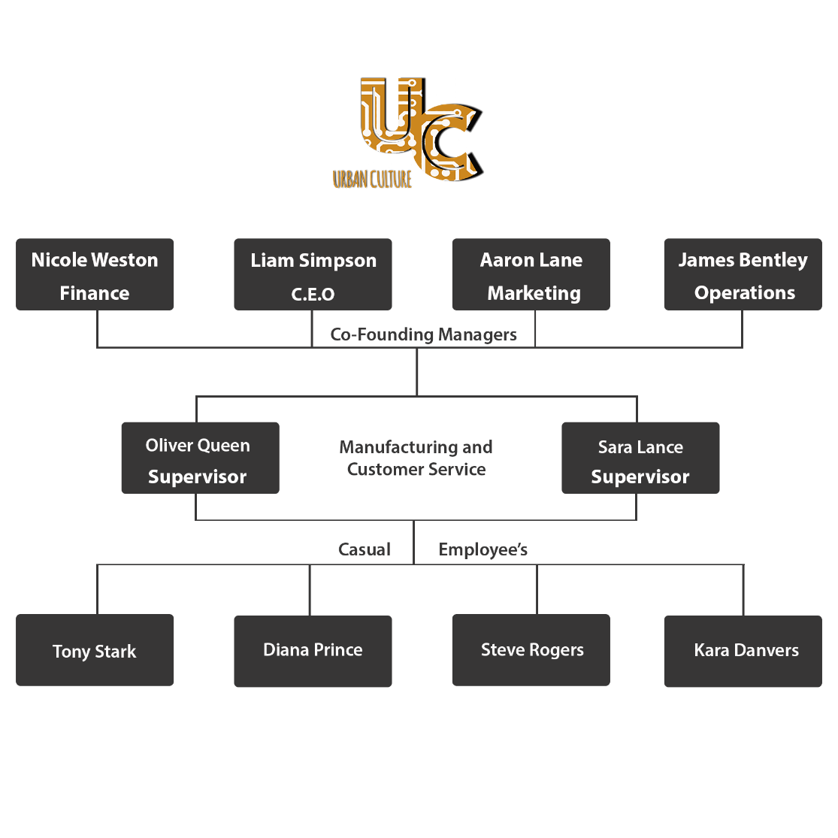*Note the cofounding managers form the company’s board of directors.

## Recruiting

Recruitment is a significantly influential factor on the long-term success of a business. Urban Culture Co aims to employ a maximum of eight casual employees and two full-time supervisors for the purposes of manufacturing and customer service. The recruitment process will be monitored closely to ensure all applicants that progress to the stage of an interview meet all of the requirements.

|  |  |
| --- | --- |
| **Requirements of Applicants for Casual Positions** | |
| Manual Driver’s License | Understanding of technological concepts (Hardware and Software) |
| Customer Service Experience | Experience working in/as a team/group |
| Flexible Lifestyle | Able to operate power tools safely |
| Great Communication/Social Skills | No previous issues with employment  (termination, suspension, injury) |
| Fluent in the English Language | Able to stand for prolonged periods |
| **Requirements of Applicants for Full-time Supervisor Positions** **(In addition to the previous)** | |
| Previous Management Experience | Business Management Qualification/s  (Diploma, Bachelor's, Master’s etc.) |
| Able to make decisions quickly | Superior understanding of technological concepts |
| Trained in First Aid | Trained in Safe Work Practice |

***The interview process (Stage 2) for all successful Stage 1 applicants will consist of;***

|  |  |
| --- | --- |
| **The Interview Process** | |
| 1. Brief Intro to Urban Culture | 4. Discussion of Availability |
| 2. Job Discussion | 5. What do they have to offer U.C? |
| 3. Discussion of Suitability | 6. Discussion of Work Environment |

All Stage 2 applicants will be contacted by phone and told if they have been successful or unsuccessful during the recruitment process. All successful applicants will be required to attend a PAID induction session prior to starting work.

## Retaining

It is crucially important for all businesses to implement and design strategies for facilitating employee retainment. Urban Culture has developed a strategy that operates on 3 tiers. A large focus has been targeted onto developing employees into trustworthy, hard-working individuals who enjoy working in Urban Culture’s friendly working environment productively. The first tier focuses on the relationships within and outside of the organisation, specifically facilitating employee relationships with others and management. Tier 2 affects all general circumstances associated with Urban Culture and includes specifically financial incentive in the form of weekly casual wages for casual employees, and a signed contractual agreement including a yearly salary with added benefits for full-time supervisors. Tier 3 invokes the payments and beneficiaries to employees for special circumstances including but not limited to promotion. Special rewards include; paid and unpaid leave, bonus payments, over-time payments, pay-rises and in the situation of a corporation; investment shares in the company may be supplied.

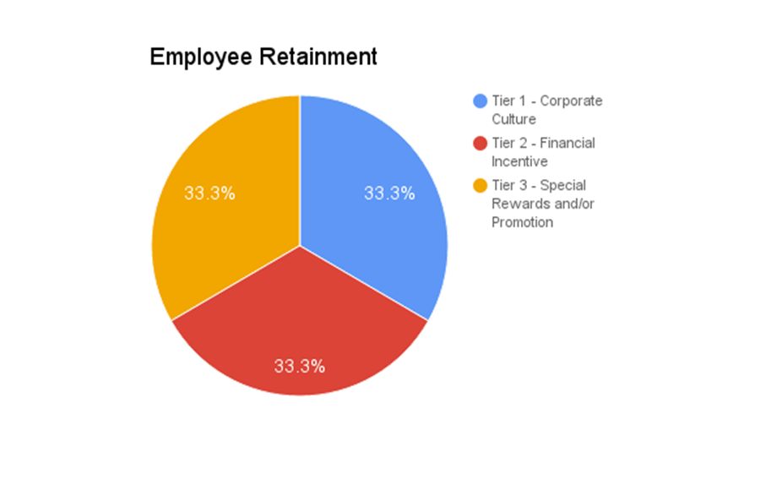

## Award Rates

Urban Culture employs Australian and international citizens. Australian citizens must be able to show an Australian birth certificate and internationals must provide information for a valid work VISA. The tables below provide the award wages and salaries for ALL job roles associated with Urban Culture. Award information is provided by Fair Work Australia minimum wage pay guides for Amusement, Events and Recreation Award 2010.

***Refer to Appendix A for tabulated financial information.***

# Website Design and Implementation

## Security

Security is a major point in information technology and by extension any business that relies upon it. Currently, web servers are being attacked constantly with various types of traffic in an attempt to exploit problems with the systems security. For example, a denial of service attack may cost someone $150 a week to have someone do it and one report find it has more than 2000 attacks of this type on their network daily with 1/3 of all downtime caused by denial of service[7]. Because of these facts security is considered extensively in this section. If a site is slow to load or offline then customers may not buy from us resulting in losses of revenue which for an online business, can be disastrous.

## Direct Denial of Service (D/DOS)

DDoS attacks have become a common means used to take a website offline. The main ways these attacks happen is either through the use of a bot net to flood the server with requests and overwhelm it with pure volume, using a TCP connection to tie up a connection at the first point of contact with the network (load-balancers, firewalls, application servers and etc.) or by sending lots of fragmented packets for the server to reassemble. There are many ways to combat this such as specifying a short keep alive timeout for connections or with other services that try and prevent amplification/ volume based attacks.

## Version and Application Vulnerabilities

Applications are commonly found to be vulnerable and are patched to fix the problems found. If applications on server side are not up to date this could create open security holes for the business. This can be combated by keeping applications up to date and knowing about vulnerabilities. Another example of this is SQL injection which would in worst cases allow an attacker to impersonate users or use queries that cause the whole database as an output in addition to permissions a specific user has like changing, reading or erasing records.

## Port and Server Vulnerabilities

If a port is not being used, then leaving the port open is bad practice. A surprising amount of servers leave ports open which are not in use which creates a vulnerability for the system. For example, a lot of servers leave TCP port 22 as listening (default for SSH) to connect to the server via the internet but this should only be done with precautions in place. From Norse map[8] (a map of live attacks) common attacks at the moment are 5060 (SIP protocol) which is probably being used to exploit vulnerabilities in VOIP equipment using that protocol, port 5900 (Remote Frame Buffer (RFB)) which is used by a remote control application for helpdesk and remote support and is likely people trying to exploit those applications and port 25 (SMTP) an e-mail protocol which may be being used to verify valid email addresses with the server or might even be used to cause the server to show what mailing lists exist through a telnet session.

# Financial Strategy

***\*\*I am updating the larger Income statement and estimated cash flow statement in excel. However, it will be way too large to upload here. We will have to have 2 A3 pages folded for this section so maybe keep it separate.\*\****

***Note: I am also going to try and get some graphs done***

# 8.0 Bibliography

**There are no sources in the current document.**

# Appendix

## Appendix A

**Business Model**

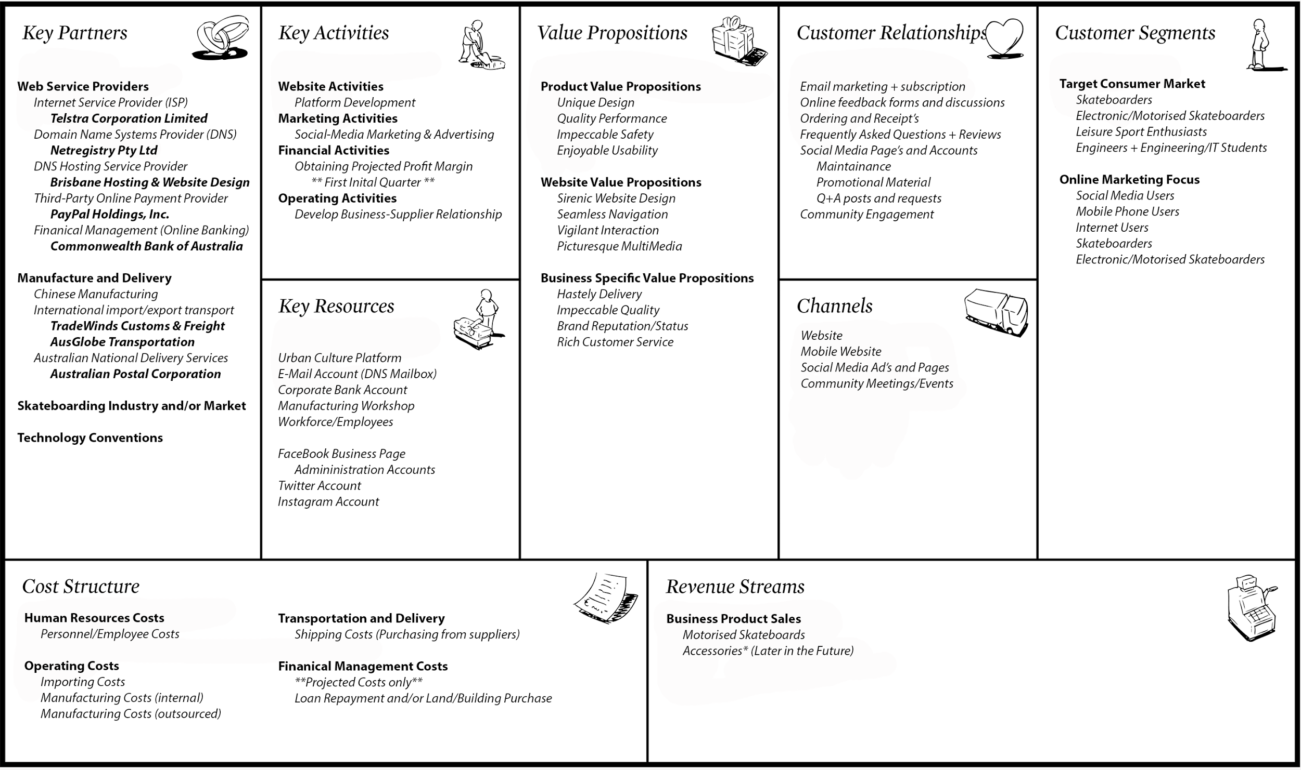

**Award Rates**

***Adult - Full-time and Part-time employees***

|  |  |  |  |  |  |  |
| --- | --- | --- | --- | --- | --- | --- |
| **Classification** | **Weekly pay rate** | **Hourly pay rate** | **Public holiday** | **Overtime - first 3 hours** | **Overtime - after 3 hours** | **Minimum break between shifts** |
| Introductory | $656.90 | $17.29 | $43.23 | $25.94 | $34.58 | $34.58 |
| Grade 1 | $675.90 | $17.79 | $44.48 | $26.69 | $35.58 | $35.58 |
| Grade 2 | $701.80 | $18.47 | $46.18 | $27.71 | $36.94 | $36.94 |
| Grade 3 | $725.90 | $19.10 | $47.75 | $28.65 | $38.20 | $38.20 |
| Grade 4 | $764.90 | $20.13 | $50.33 | $30.20 | $40.26 | $40.26 |
| Grade 5 | $788.80 | $20.76 | $51.90 | $31.14 | $41.52 | $41.52 |
| Grade 6 | $812.70 | $21.39 | $53.48 | $32.09 | $42.78 | $42.78 |
| Grade 7 | $834.60 | $21.96 | $54.90 | $32.94 | $43.92 | $43.92 |
| Grade 8 | $876.90 | $23.08 | $57.70 | $34.62 | $46.16 | $46.16 |
| Grade 9 | $971.00 | $25.55 | $63.88 | $38.33 | $51.10 | $51.10 |

***Adult - Casual Employees***

|  |  |  |  |  |  |
| --- | --- | --- | --- | --- | --- |
| **Classification** | **Hourly pay rate** | **Public holiday** | **Overtime - first 3 hours** | **Overtime - after 3 hours** | **Minimum break between shifts** |
| Introductory | $21.61 | $47.55 | $30.26 | $38.90 | $38.90 |
| Grade 1 | $22.24 | $48.92 | $31.13 | $40.03 | $40.03 |
| Grade 2 | $23.09 | $50.79 | $32.32 | $41.56 | $41.56 |
| Grade 3 | $23.88 | $52.53 | $33.43 | $42.98 | $42.98 |
| Grade 4 | $25.16 | $55.36 | $35.23 | $45.29 | $45.29 |
| Grade 5 | $25.95 | $57.09 | $36.33 | $46.71 | $46.71 |
| Grade 6 | $26.74 | $58.82 | $37.43 | $48.13 | $48.13 |
| Grade 7 | $27.45 | $60.39 | $38.43 | $49.41 | $49.41 |
| Grade 8 | $28.85 | $63.47 | $40.39 | $51.93 | $51.93 |
| Grade 9 | $31.94 | $70.26 | $44.71 | $57.49 | $57.49 |

## 9.2 Appendix B

1. <http://www.abs.gov.au/ausstats/abs@.nsf/0/9C7742890ADEC989CA2568A900139423?Opendocument>
2. <https://www.business.qld.gov.au/business/starting/business-startup-options/business-legal-structures/setting-up-a-legal-business>
3. <http://www2.deloitte.com/uk/en/pages/press-releases/articles/one-in-three-consumers-wants-personalised-products.html>
4. <https://yougov.co.uk/profileslite#/Skateboarding/personality>
5. <http://www.outdoorfoundation.org/pdf/ResearchParticipation2013.pdf>
6. <http://www2.deloitte.com/uk/en/pages/press-releases/articles/one-in-three-consumers-wants-personalised-products.html>
7. <http://www.digitalattackmap.com/understanding-ddos/>
8. <http://map.norsecorp.com/#/>